**1)What is Semi-group?**

**2)Define lattice?**

**3)Define Normal Sub-group?**

**4)What is monoid?**

**5)How many words can be formed by using the letters from the word “DRIVER” such that all the vowels are never together?**

**6)How many words can be formed by using the letters from the word “DRIVER” such that all the vowels are never together?**

**7)What is sum rule and product rule?**

**8)How many integers from 1 to 50 are multiples of 2 or 3 but not both?**

**9)Define binomial coefficient?**

**10)In how many ways can a group of 5 members be formed by selecting 3 boys out of 6 boys and 2 girls out of 5 girls?**

**11)How many different outcomes are possible by tossing 10 similar coins?**

**12)In how many ways can be cricket team of 11 being choosen out of 14 players.How many of them**

**i)including a particular player**

**ii)excluding a particular player**

**13)What is subgraph with an example?**

14) **What is the difference between graph and tree?**

15) **Define planar graph?**

**16) In a connected planar graph G there are 8 vertices,5 faces find the number of edges in G?**

**17)Define about multi-graph?**

**18)If a graph has 5 vertices of degree 4 and 4 vertices of degree 3.How many edges does the graph have?**

**19)Define Chromatic Number?**

**20)Define Binary Tree?**

1) **Breifly explain about lattice?what are the properties of lattice? Check whether the following diagram is lattice or not?**

3

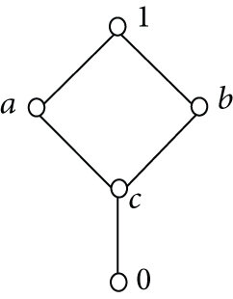

2) **What is the simplified sum of product form for the Boolean expression:**

**(A + B’ + C’)(A + B’ + C)(A + B + C’)3**

**3) Consider an algebraic structure (Q, *) where Q is set of rational numbers and ‘*’ is a multiplication operation. Determine whether (G, *) is a commutative monoid for the algebraic expression a*b = a+b-ab?**

3

4) **Using Boolean identities, reduce the given Boolean expression:**

**F(X, Y, Z) = X′Y + YZ′ + YZ + XY′Z′3**

**5) There are 350 farmers in a large region. 260 farm beetroot, 100 farm yams, 70 farm radish, 40 farm beetroot and radish, 40 farm yams and radish, and 30 farm beetroot and yams. Let B, Y, and R denote the set of farms that farm beetroot, yams and radish respectively.Determine the number of farmers that farm beetroot, yams, and radish?4**

**6) a) How many 4-digit numbers can be formed using the digits 2,3,5,6,8 and 9 if repetitions are allowed?**

**b) How many if no repetitions are allowed?**

**c) How many if those in (b) are even numbers?**

**d) How many of those numbers in (b) are greater than 4000?**

**e) How many of those in (b) are divisible by 5?**

**7) Prove C(n+4,r)=C(n,r)+4C(n,r-1)+6C(n,r-2)+4C(n,r-3)+C(n,r-4).**

**8) In a survey of students at Florida State university the following information was obtained: 260 were taking a statistics course,208 were taking a mathematics course,160 were taking computer programming course,76 taking statistics and mathematics,48 were taking statistics and computer programming,62 were taking mathematics courses and computer programming,30 were talking all 3 kinds of courses,and 150 were taking none of the 3 courses**

**Let S={students taking statistics}**

**M={students taking mathematics}**

**C={students taking computer programming}**

1. **How many students surveyed?**
2. **How many students were taking statistics and mathematics course but not computer programming course?**
3. **How many were taking statistics and computer course but not mathematics?**
4. **How many were taking a computer programming and mathematics course but not statistics course?**

**9) Define graph isomorphism and determine the following graphs are isomorphic are**

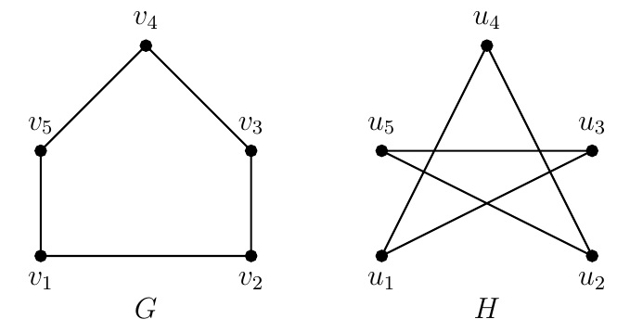

10) **Breifly explain about Hamilton circuit, Hamilton cycle and Hamilton path and Hamilton graph with an example?**

**11) Construct spanning tree for the following graph using kruskal’s Algorithm**

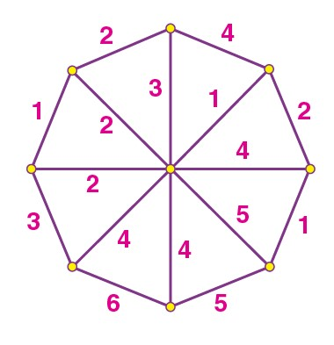

12) **Explain about eulerian cycle and eulerian path and how does it work? The following graph is eulerian graph or not?**

